Ideas / inspiration

When discussing 2D video games, their design, devolvement and studio’s ability to overcome limitations, it has hard not to included Nintendo’s contribution with the likes of Zelda and Mario. Two franchises still around today.

When discussing with our team, we all showed interested in puzzle games. With the skills and knowledge that we have gained through this course and our assignment 1, we thought that we had a good foundation for building a *dungeon crawling Zelda* like game.

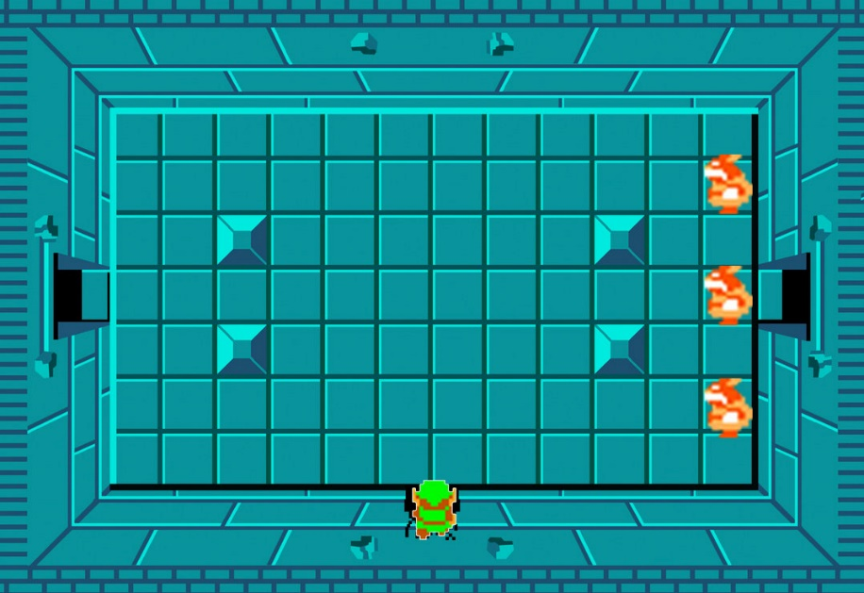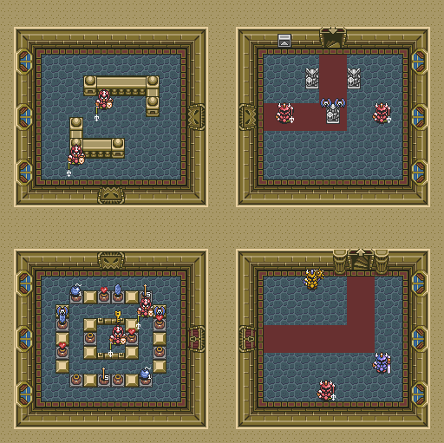The room-based puzzles of Zelda’s dungeons were the source of inspiration for us to build a game, that has players complete grid-based maze puzzles to procced to the next level.

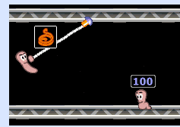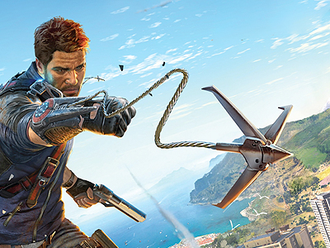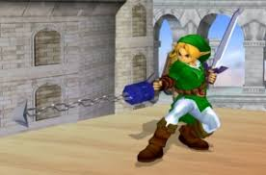To enhance the game and the player’s experience, we wanted to add an ability that improved the players simple grid-based movement. To achieve this, we decided to give the player a grappling hook ability. Not only does this make the player’s movements more enjoyable, but it also allowed us to develop the level / maze design around this ability.

Game Design

With the key ideas of a rooms, where the player needs to navigate a maze, using standard movement and a grappling ability, we were able to start working on the game design.

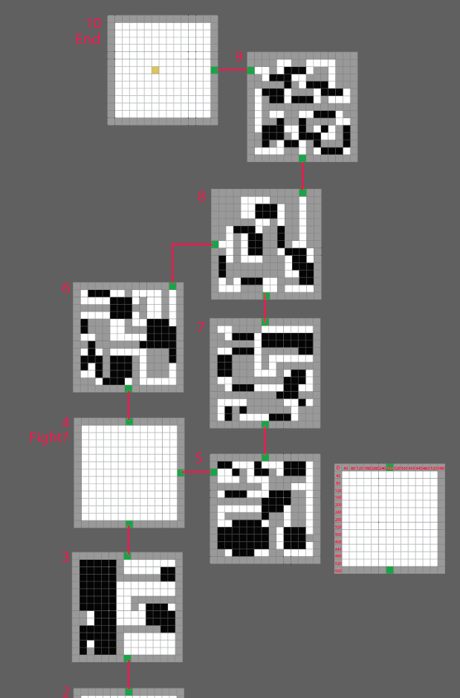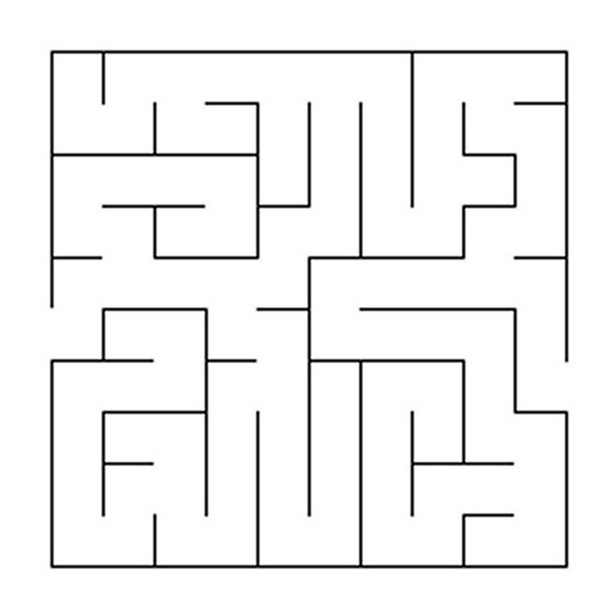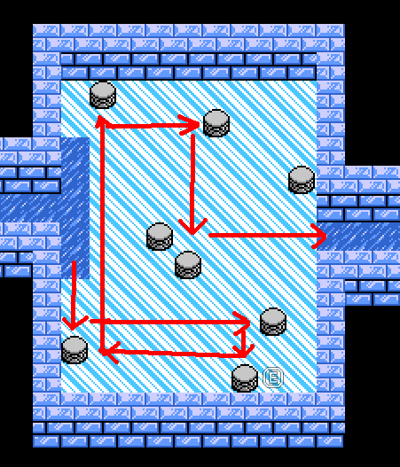This started with researching different maze ideas and applying this knowledge to our game’s mechanic. From here we were able to start to design each room’s layout and make sure the maze and game play fitted together.

To merry the maze style and grappling ability together, we used a ground hazard in which the player would need to traverse with their grabbling ability in order to continue. Rules were placed on the grappling ability in order to define what was achievable for the player while using the ability. This then helped us fine tune the room design.

To add to the difficulty of some of the rooms, additional treasure chest were placed as optional tasks for the player. Solving how to collect these, while also finding how to complete the level betters the player’s score.

Game Features

* 10 unique rooms to solve
* 2 boss fights
* Treasures to collect to increase score
* 2 player mode, where players race to see who can complete the rooms the fastest

Group Member’s Contributions

Jerry:

* Game software architecture, core classes and base game functionalities and design.
* Animations, audio, and object interactions / events / NPC dialogues.
* GitHub repository setup and Integration of code from team members.

Josh:

* Game design and ideas.
* Grapple mechanism and design.

Helen:

* Game design and ideas.

Bryce:

* level layout design
* Level layout coding
* Menu design
* Boss fight AI design.
* Documentations.
* General bug fixes